Dear Sir,
Please modify the following issues in the website of School of Mechatronics and Robotics

Link | Problem Description | Modifications
https://www.iiests.ac.in/IIEST/AcaUnitDetails/SOMR | Image is not appearing in the AI & Humanoid Robot Lab | 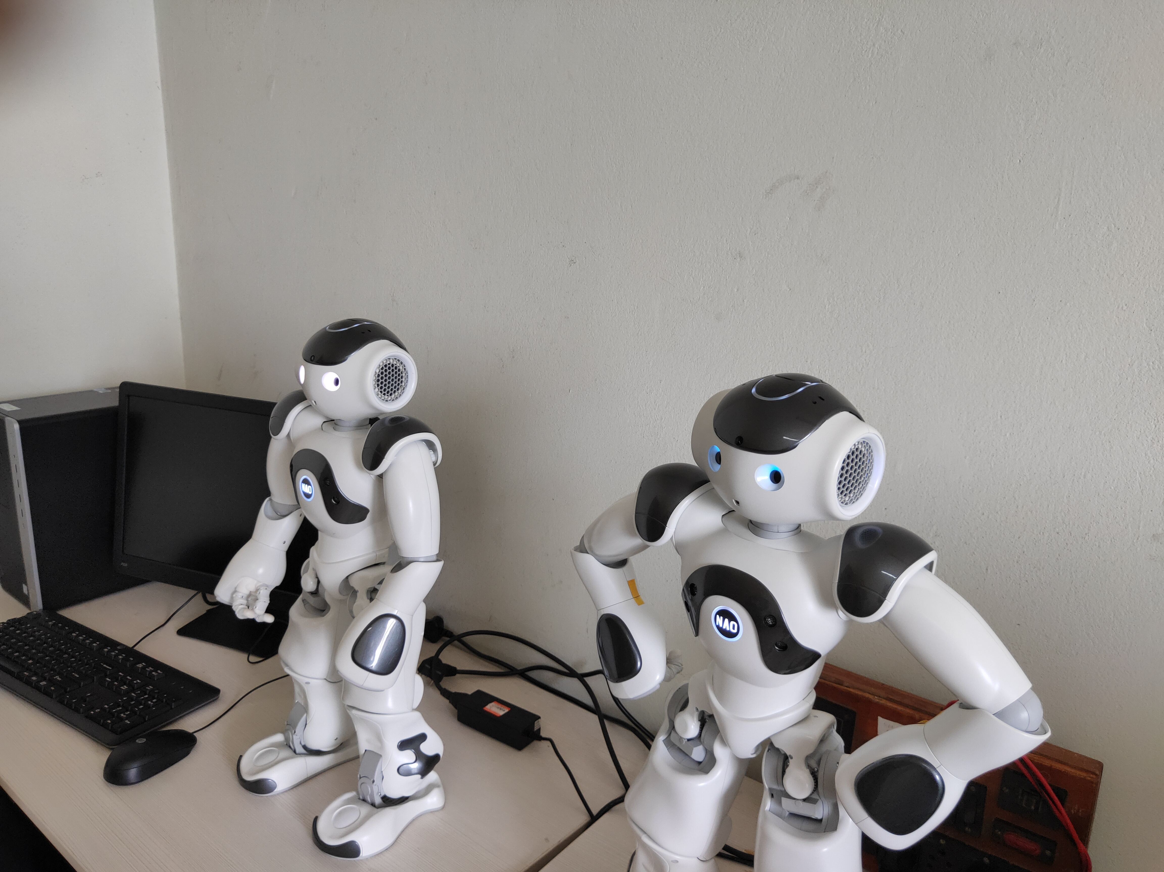  Please use this image for this lab
https://www.iiests.ac.in/IIEST/AcaUnitDetails/SOMR | The word ‘Lab’ is appearing twice in the details page.  For example see the link-https://www.iiests.ac.in/IIEST/Lab_Details/196-additive_manufacturing_lab  Consequently, The laboratory name has become ‘Additive Manufacturing Lab Lab’. This error is present for all laboratories name. | Please remove the Lab/Laboratory word from the page https://www.iiests.ac.in/IIEST/AcaUnitDetails/SOMR
https://www.iiests.ac.in/IIEST/AcaUnitDetails/SOMR - Facilities | After clicking on ‘Bio-robotics, Haptics & VR Laboratory’ it shows an error message. The following page appears https://www.iiests.ac.in/IIEST/Lab_Details/199-bio-robotics,_haptics___vr_laboratory | Please make sure that the contents corresponding to ‘Bio-robotics, Haptics & VR Laboratory’ is displayed properly.
https://www.iiests.ac.in/IIEST/AcaUnitDetails/SOMR - Facilities | All the names should be uniform. | The term ‘Lab’ should be converted to ‘Laboratory’.
https://www.iiests.ac.in/IIEST/AcaUnitDetails/SOMR | The content of Sl.No. 10. “Research Poster  https://tinyurl.com/research-poster-smr-iiest” should be removed | Please include this information “Research Poster  https://tinyurl.com/research-poster-smr-iiest” at Gallery page
https://www.iiests.ac.in/IIEST/StudDetails/?id=NDc4 | The format of date ‘07 J 2016 ’ is invalid  and supervisor name is not appearing | Change the date format as dd/mm/yyyy. Please add Prof Subhasis Bhaumik as hi Supervisor

